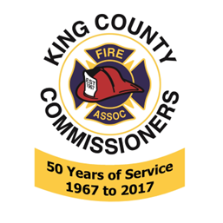
King County Fire Commissioners Association
General Membership
April 8th 2026

Call to order, 7pm
In Attendance: Kim Fischer, Rod Heivilin, Anita Sandall, Barb Sullivan, Chris Elwell, David Harris, Jerry Smith, Ray Mullen, Andy Adolfson
Guest Speaker: Jay Fischer Oklahoma City Bombing
(technical difficulties trying to screen share)

Minutes approval from March 11, 2026, (No minutes recorded for Jan 14, 2026) KCFCA General meeting motion to approve by Jerry Smith, Ray Mullen 2nds. Motion passes unanimously.

Treasurer Report: Jerry Smith motions to accept report, Kim 2nds, Motion passes unanimously.

Committee/Team Reports
Membership Committee Kim Fischer Nothing new, updating roster for King County Commissioners
Webpage Barb sent out test email from website
WFCA Region 6 Chris Elwell not in attendance
Legislative nothing to report.
PSERN No report
EMAC did not attend today
EMSAC Notes from meeting read will post to website
Regional Trauma Care Council John Murphy: UW campus EMS responses, TCC campaign Prevention kids falling out of windows. Report on Wait times, wall times, and diversion of EMS units.
Other Committee/ Team reports
LEPC meets quarterly no report
NAEFO No report
Old Business: Jeri Taylor Swade volunteered for a secretary position with us.
New Business: nothing new
Good of the Order
Adjournment 8:17pm Jerry motions to adjourn, Kim2nds meeting adjourn.

