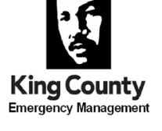
AGENDA
Emergency Management Advisory Committee (EMAC)
Wednesday April 8, 2026| 10:00-12:00pm
3511 NE 2nd St, Renton

Objectives:
- Convene in Person
- Discuss a scenario for communicating with partners and the public during FIFA World Cup
__________________________________________________________________________________________________
Coffee and Networking optional 9:30-10:00am

Welcome and Introductions 10:00am
- Sign in Carl Lunak, Chair

Approve Meeting Minutes (March) EMAC, All

FIFA World Cup Communication and Alerting TTX Lite EMAC, All

Good of the Order EMAC, All

Next Meeting
May 13, 2026 | 10:00 – 11:30am
Virtual Only

